**Wireshark**

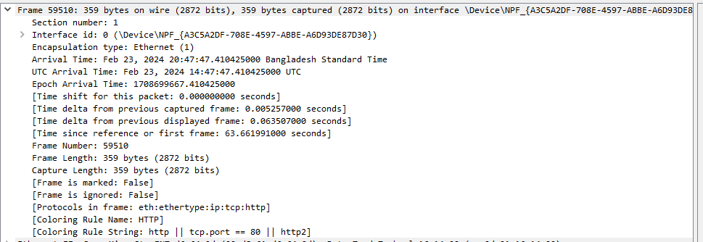



**Ethernet II:** Type of ethernet.

**Source:** Refers Mac Address. MAC address: 00:dB:61:d6:64:9d

**Destination:** Indicates the MAC address of the intended recipient. (cc:2d:16:14:00)

**Type:** Sets the type of data that is contained within the Ethernet frame. The number "0x0800" in hexadecimal tells us that it's IPv4.

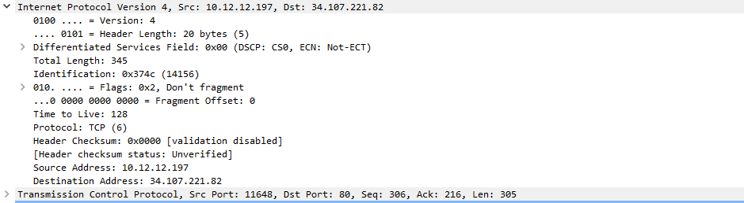

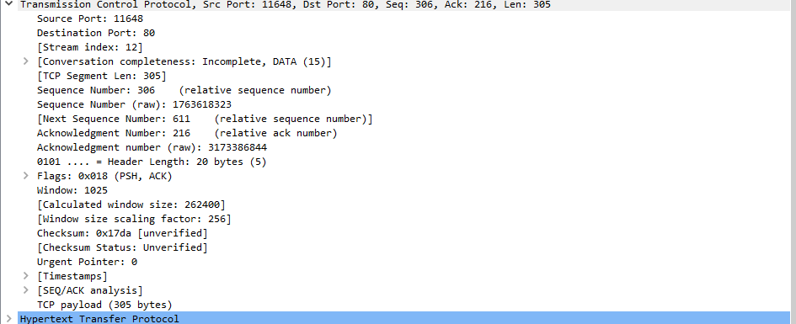

* The source port is 11648, indicating the port from which the segment originates.
* The destination port is 80, indicating the port to which the segment is being sent.

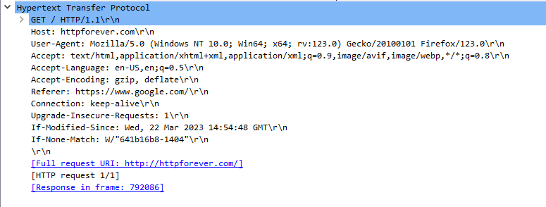

**GET / HTTP/1.1:** This line shows the HTTP version being used, the HTTP method being used (GET), and the item being asked for. HTTP/1.1.

**Host:** httpforever.com. It’s the domain name which the request is being sent.

**User-Agent:** It defines the client that is Mozilla Firefox and the version is 123.0 in windows 10 operating system.

**Accept:** The viewer can handle HTML, XHTML, XML, AVIF, Web, and any other type that isn't as important.

**Accept-Language:** The preferred language of the response content is English.

**Referer:** The URL of the web page from which the request originated.

**Connection:** This value tells the server whether to keep the link open for more requests or close it after this one.

**Cookie:** This includes any cookies that are linked to the domain. These are usually used to handle sessions or keep track of what users are doing.

**Upgrade-Insecure-Requests:** This value means that the client would like to use a secure connection (HTTPS) to access the resource if one is accessible.